LAB EXPERIMENT RECORD

Set 7: Customer Demographics Analysis

Department | AIML
Course Code / Course Name | DSA0602 / Data Handling and Visualization
Experiment | Data Visualization using R and Tableau
Name | S.Naveen Kumar
Register Number | 192425176
Date | 3 October 2026
Day | Saturday

Aim
To analyze customer demographics by visualizing the distribution of customer ages using a bar chart, the distribution of customers by gender using a pie chart, presenting the demographic information in a labelled table, and combining all three views in an interactive Tableau dashboard.

Dataset: Customer Demographics

Customer ID | Age | Gender | Income (in $)
1 | 28 | Female | 50000
2 | 35 | Male | 60000
3 | 42 | Female | 75000

PROGRAM 1: Bar Chart of Customer Ages
Create a bar chart to visualize the distribution of customer ages. Label the axes and title the chart.

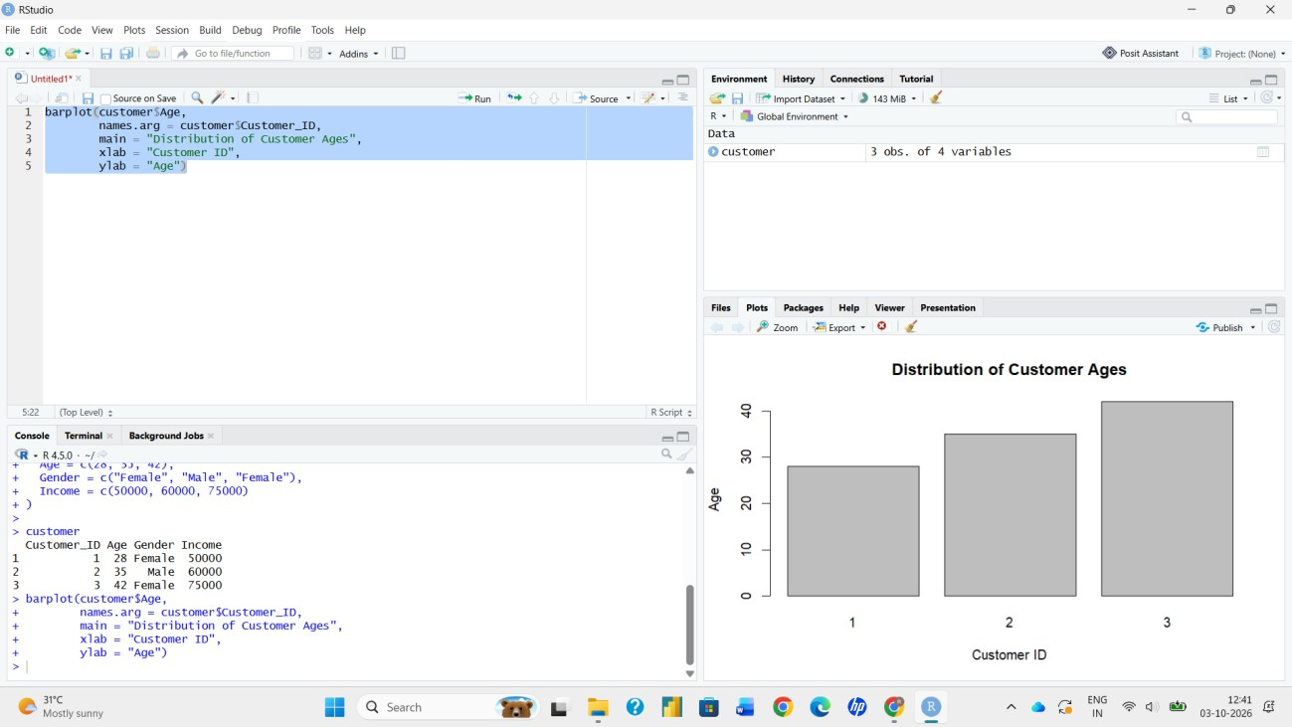
# Dataset
customers <- data.frame( Customer_ID = c(1, 2, 3),
Age = c(28, 35, 42),
Gender = c("Female", "Male", "Female"), Income = c(50000, 60000, 75000)
)

# Bar Chart barplot(customers$Age,
names.arg = customers$Customer_ID, xlab = "Customer ID",
ylab = "Age (years)",
main = "Distribution of Customer Ages", col = "skyblue")

Output 1: Customer Age Bar Chart
Observation: The ages of the three customers are 28, 35 and 42 years. Customer 3 is the oldest and Customer 1 is the youngest, and the average customer age is 35 years.

PROGRAM 2: Pie Chart of Customers by Gender
Generate a pie chart to represent the distribution of customers by gender.

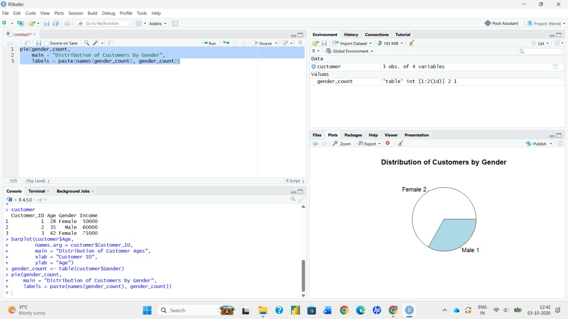
# Count customers by gender gender_count <- table(customers$Gender)

# Percentage labels
percent <- round(100 * gender_count / sum(gender_count), 1) labels <- paste0(names(gender_count), " (", percent, "%)")

# Pie Chart pie(gender_count,
labels = labels,
col = c("pink", "lightblue"),
main = "Customer Distribution by Gender")

Output 2: Customer Gender Distribution Pie Chart
Observation: Two of the three customers are female (66.7%) and one is male (33.3%), so female customers form the larger share of this dataset.

PROGRAM 3: Table of Customer Demographic Information
Build a table to show the demographic information for each customer. Label the table elements.

# Build and label the table demographics <- customers
colnames(demographics) <- c("Customer ID", "Age", "Gender", "Income (in $)")

print(demographics)

 | Cus  1 | tomer ID Age Gen  1 28 Female | der Income (in  50000 | $)
 | 2 | 2 35 Male | 60000
 | 3 | 3 42 Female | 75000
 |  |  |  | Output 3(a): R Console Output

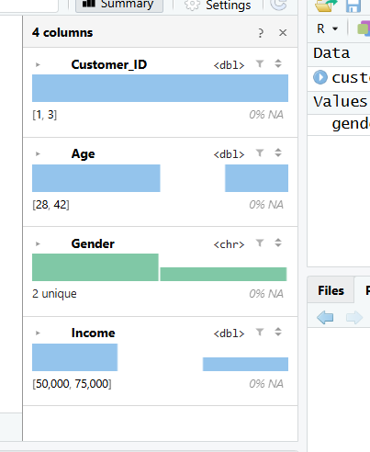

Output 3(b): Customer Demographic Information Table
Observation: The table lists the Customer ID, Age, Gender and Income of every customer. Income increases with age, from $50,000 for the 28-year-old customer to $75,000 for the 42-year-old customer, with an average income of about $61,667.

PROGRAM 4: Interactive Tableau Dashboard
Develop a Tableau dashboard combining the bar chart, pie chart, and the table for interactive exploration of customer demographics.
- Open Tableau and choose Connect > Text file (or Microsoft Excel), then select the customer demographics file (Customer ID, Age, Gender, Income).
- Open Sheet 1 and create the bar chart: drag Customer ID to Columns and Age to Rows (set Age to SUM or to a Dimension). Add labels, rename the sheet to “Customer Ages” and title it.
- Open Sheet 2 and create the pie chart: change the Marks type to Pie, drag Gender to Color and Customer ID (Count) to Angle. Show percentage labels and rename the sheet to “Gender Distribution”.
- Open Sheet 3 and create the table: drag Customer ID, Age, Gender and Income to Rows (or double-click each field) to display the text table. Rename the sheet to “Customer Details”.
- Click New Dashboard. Drag the three sheets onto the dashboard canvas and arrange them as shown in the output.
- Right-click the Gender field > Show Filter, then use the filter’s dropdown > Apply to Worksheets > All Using This Data Source.
- Select the pie chart and click “Use as Filter” so that clicking a gender slice highlights the matching bars and table rows.
- Add a dashboard title, and test the interactivity by selecting Female or Male.
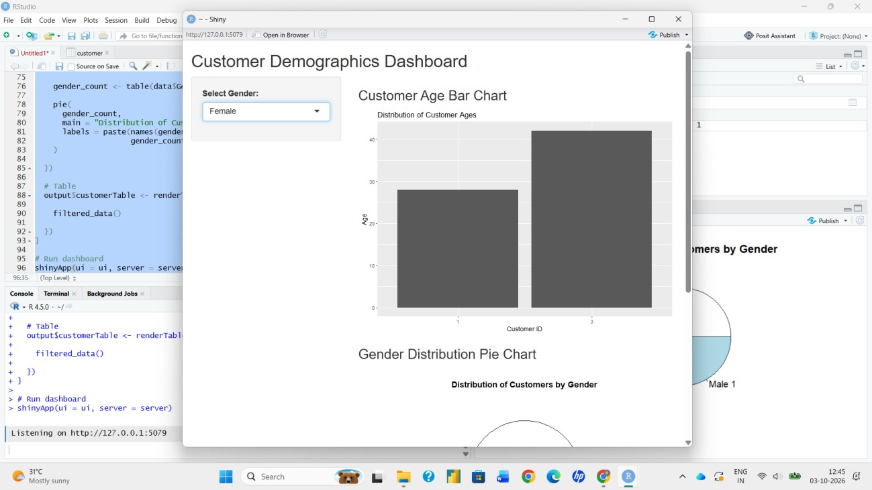
Output 4: Customer Demographics Tableau Dashboard
Observation: The dashboard shows ages, gender share and individual records together. Selecting a gender filters all three views at once, which lets the user explore the demographics interactively.

Procedure
- Create the customer data frame with Customer_ID, Age, Gender and Income in R.
- Use barplot() to plot the customer ages with labelled axes and a title.
- Use table() to count customers by gender and pie() to draw the gender distribution.
- Rename the data frame columns with colnames() and print the labelled demographic table.
- Load the data into Tableau, build the bar chart, pie chart and table on separate worksheets.
- Combine the worksheets on a dashboard and add the Gender filter and the Use as Filter action.

Result
The customer demographics were successfully visualized using a bar chart of ages, a pie chart of gender distribution and a labelled demographic table in R. An interactive Tableau dashboard combining all three views was created for exploring the customer data.

Key Functions / Tools Used

Function / Tool | Purpose
data.frame() | Creates the customer dataset.
barplot() | Creates the bar chart of customer ages.
table() | Counts customers in each gender category.
pie() | Creates the gender distribution pie chart.
colnames() / print() | Labels and displays the demographic table.
Tableau Dashboard | Combines the worksheets into one interactive view.
Tableau Filters | Allow the user to explore the data by gender.

